|  |  |  |
| --- | --- | --- |
| Name | : | MUCHAMMAD NABIL HAYKAL WIDARTO |
| Class | : | SIB-1G |
| NIM | : | 2341760152 |

[**https://github.com/muchnabil/daspro-josheet11.git**](https://github.com/muchnabil/daspro-josheet11.git)

Experiment 1

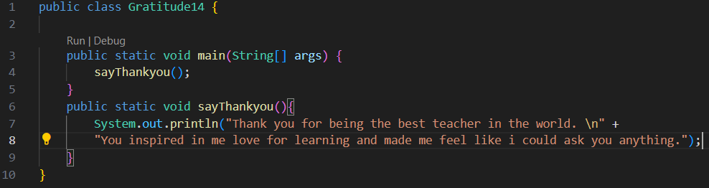

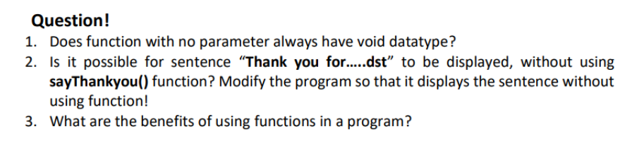

ANSWER

1. Not always

2. Yes its possible

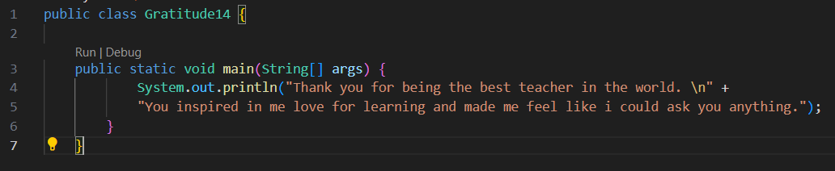

3. so the code is easy to read, understand, and can be corrected if something is errors easily.

Experiment 2

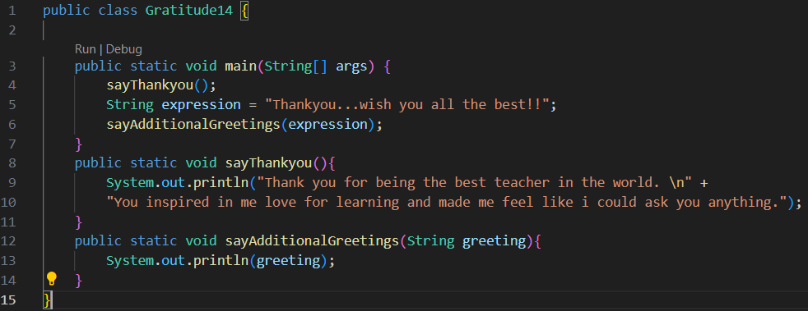

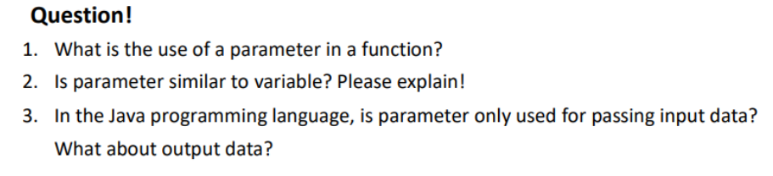

ANSWER

1. Get input data comes from the outside of the function

2. Same, because each can store data

3. No, parameter can be used for output data

Experiment 3

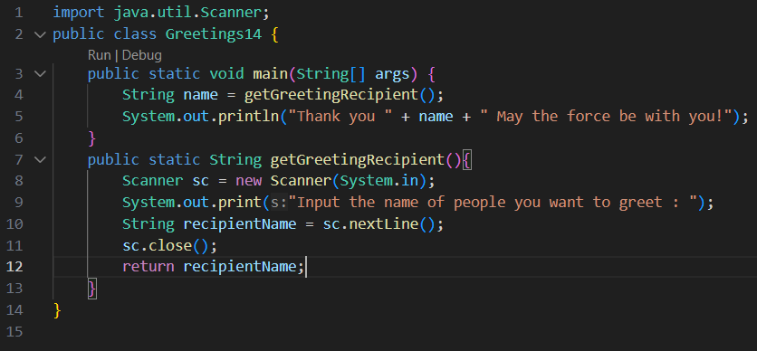

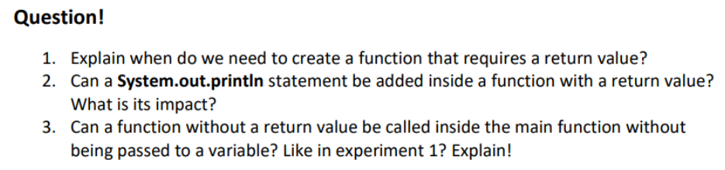

Answer

1. When we want to return a value for further processing

2. Yes it can, the impact is that the code will print before the function is completed

3. Yes it can, functions can be called inside the main function as long as there is no return value or functions with void

Experiment 4

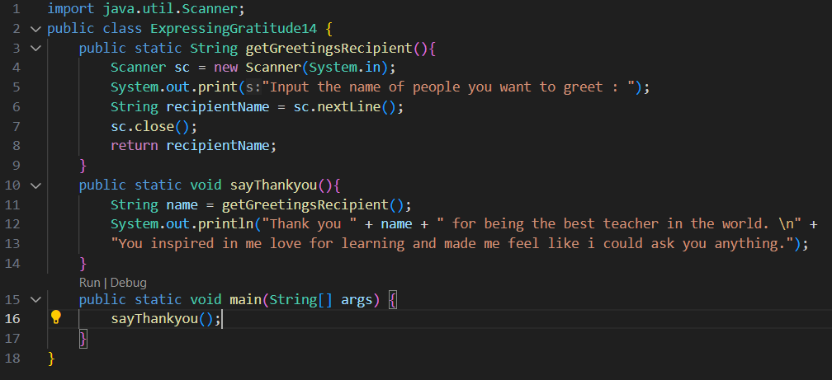

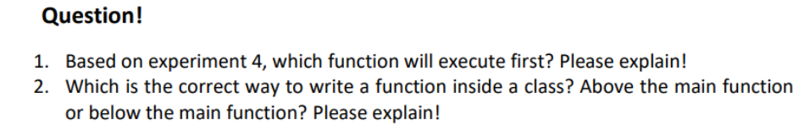

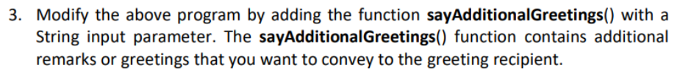

Answer

1. sayThankyou function, because that function is in the main function, when that function is executed, the getGreetingRecipient function will be executed

2. Above or below will not affect the code as long as the function is called in the main function, but it would be better if the function is placed under the main function so that the main function is easy to find

3. 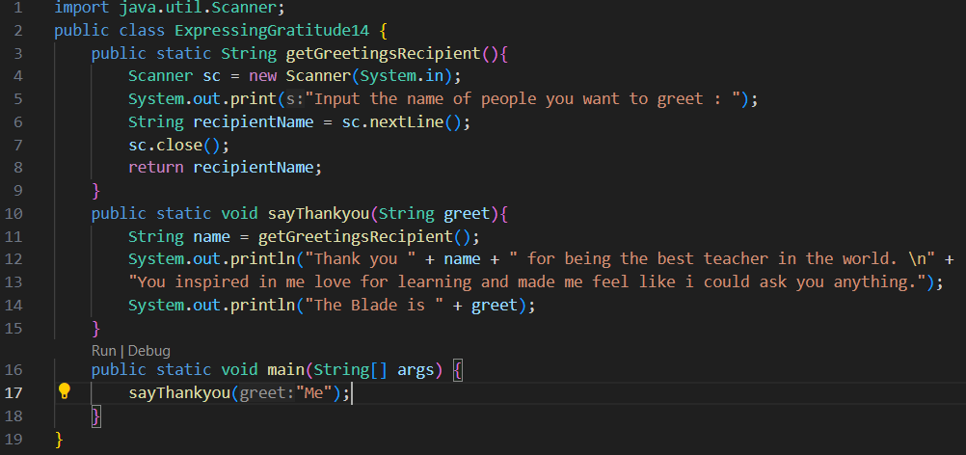

Expermient 5

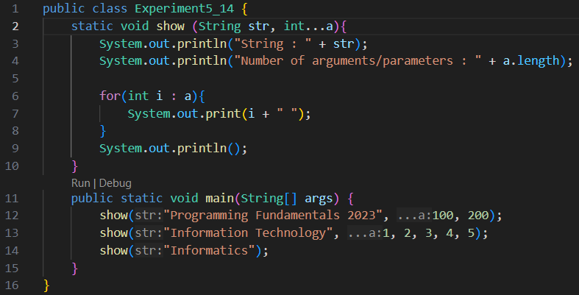

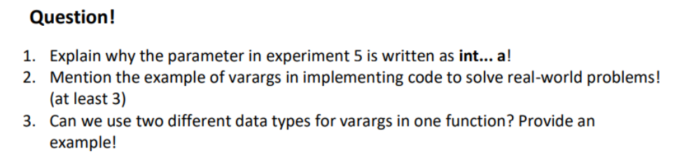

Answer

1. Because the value in parameter is more than one

2. sum multiple values, add multiple values to an array, create multiple messages

3. we cannot add two varags with the same or different data types and the varags must be in the final parameter



Experiment 6

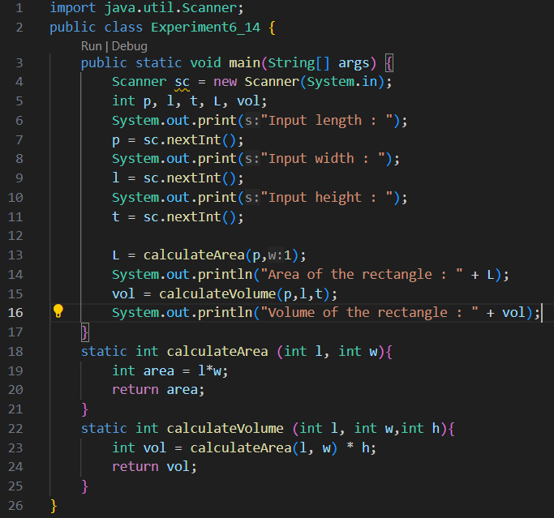

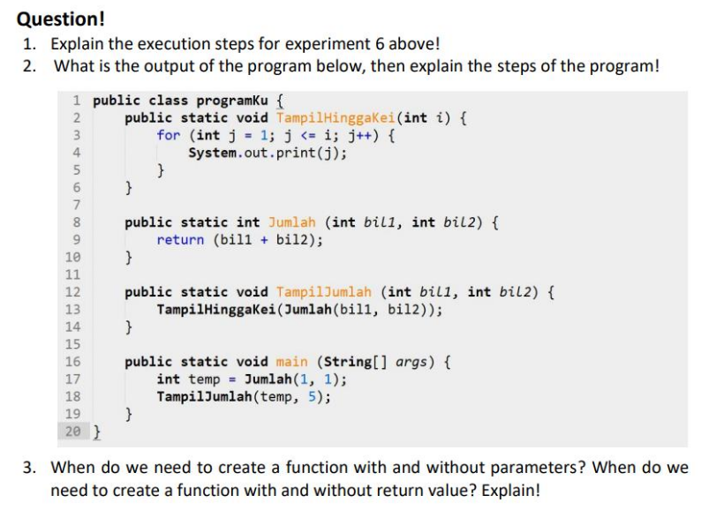

Answer

1. First will input for length, width, height and will execute the caluclateArea function which is stored in the L variable with variable parameters p(length) and l(width) then will print the L variable, then will execute the calculateVolume function which is stored in the vol variable with variable parameters t(height), p(length), l(width) then will print the vol variable.

2. 1234567, First will run the sum function to add up with parameters (1,1) which means 1 + 1, after that, the function TampilJumlah will be run with parameters (2,5) then inside this function is to call the function TampilHinggaKei with parameters (sum(2, 5)) because the sum function is called then 2 + 5 = 7 so the value of the parameter for the function TampilHinggaKei is 7. After that the function TampilHinggaKei is executed which contains a loop with the condition j <= i, j = 1 and i = 7 (from the sum of 2 + 5 in the sum function) the loop will print the value of j until it is 7.

3. A. Function with parameters is useful when you want to pass information

B. Function without parameters is useful when the function does not require any external input to perform its task.

C. Function with return value is used when you want to return an output/value for furtherprocessing

D. Function without a return value is used when the function's purpose is to perform an action but doesn't need to provide any result to the caller

Assignment

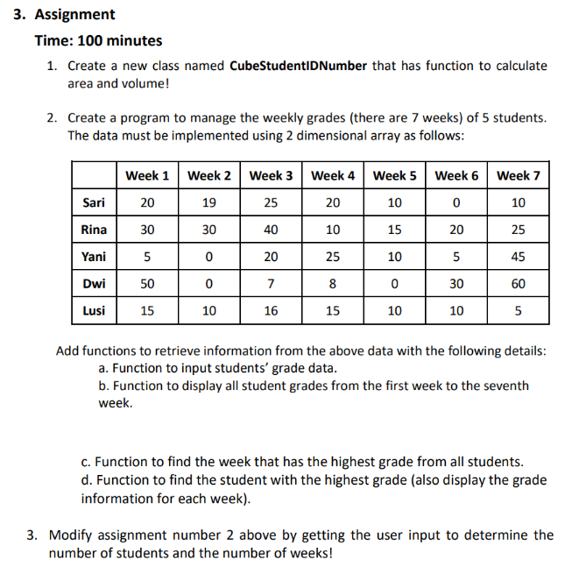

Answer

1.

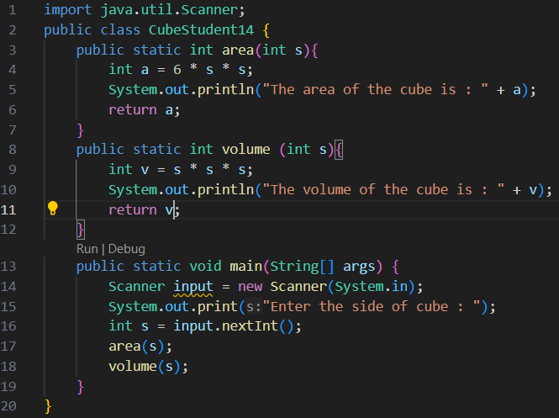

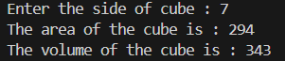

2. 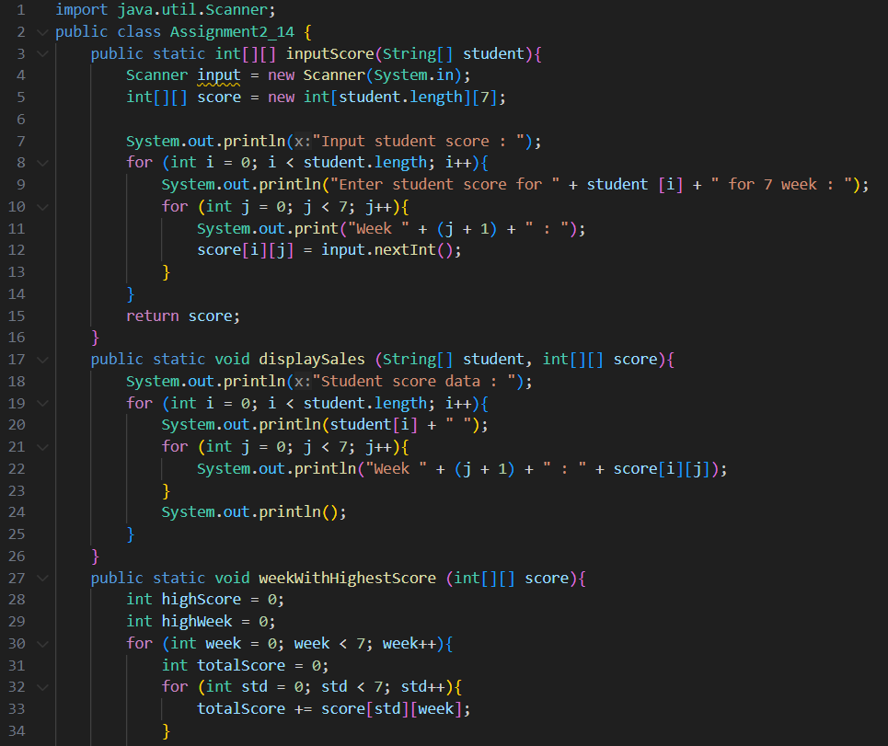

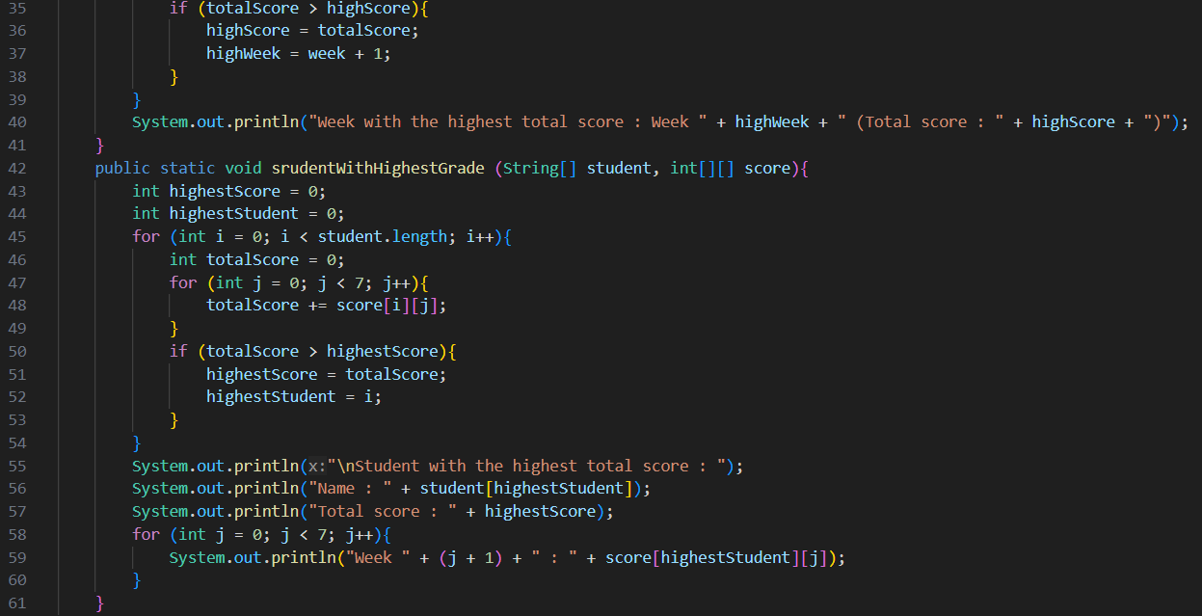

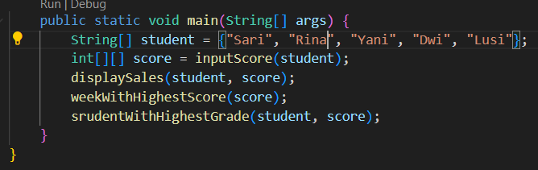

3.

